**Age Group**

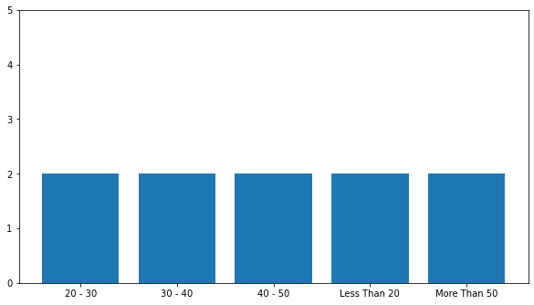

From the above plot we can see that , government employees irrespective of their age group agree that they are able to have a work-life balance.

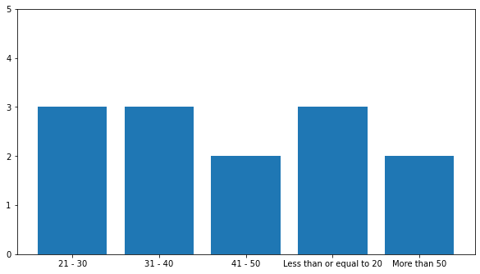

On the contrary, in the private industry it is seen that employees upto age 40 years agree that have a work life balance, where employees having age more than 40 years strongly agree that they have a work life balance.

That means we can say that over the years, as the work experience increases, the employees are better able to manage their professional and personal life.

**Gender**

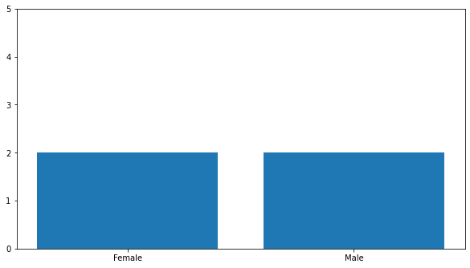

From the above plot we can see that , government employees irrespective of their gender agree that they are able to balance their work-life.

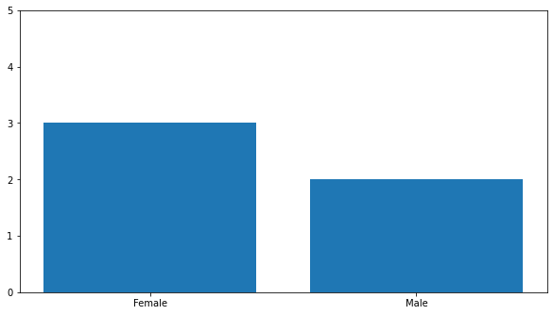

In private industry, males agree that they are able to balance their work -life while females are neutral.

**Marital status**

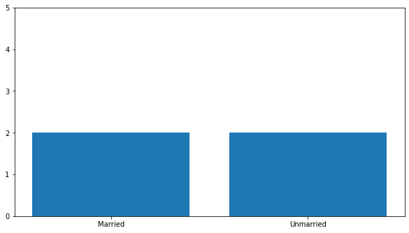

From the above graph we can see that , private employees irrespective of their marital status agree that they are able to balance their work-life.

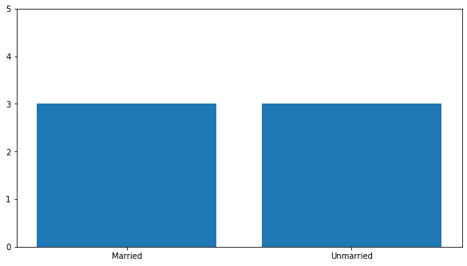

From the above graph we can see that , private employees irrespective of their marital status are neutral that they are able to balance their work-life.

**Parental status**

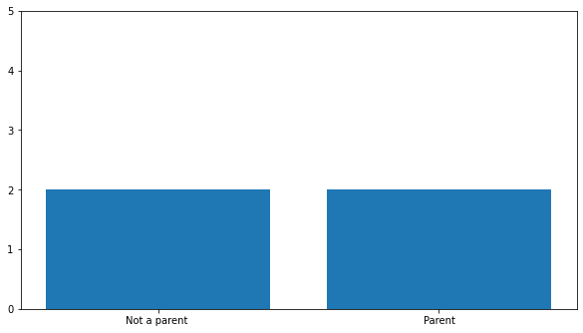

From the above plot we can see that , government employees irrespective of their parental status agree that they are able to balance their work-life.

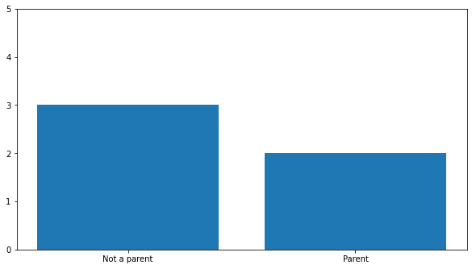

It’s surprising but private employees who are not a parent are neutral about the work life balance. Employees who are parents agree that they are able to balance their work-life.

**Working Hours**

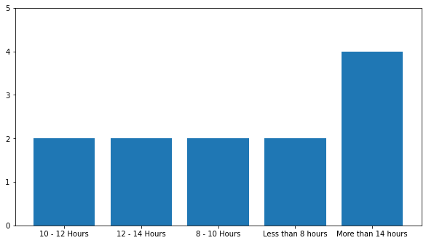

Government employees who work more than 14 hours are disagree with the fact that they are able to balance their work life. Rest agree that they can balance their work-life.

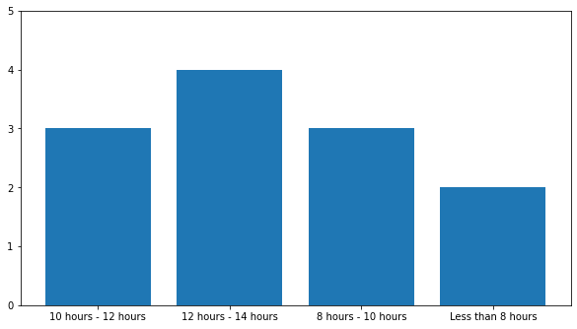

Private employees who work for more time i.e. for 12-14 hrs are disagree about balancing work and personal life. Those who work for 8-12 hrs are neutral and the ones who work less than 8 hrs agree about balancing their work life and personal life.

**Income**

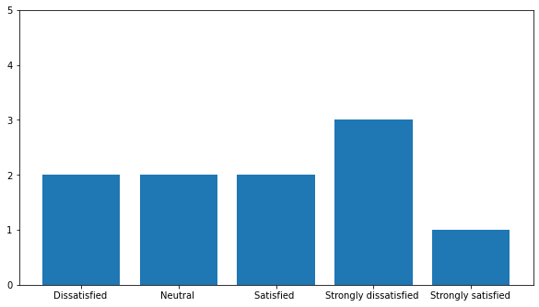

Government employees who are strongly dissatisfied with their income are neutral about the balancing work life and personal life. Others agree that they balance their work-life.

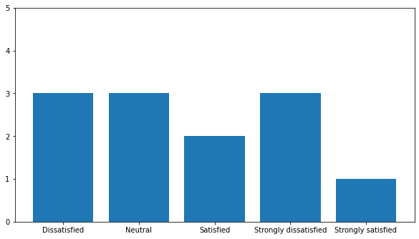

Private employees who are strongly satisfied with their income , strongly agree that they can balance their work life.

Employees who are satisfied with the income agree that they can balance their work and personal life.

Employees who are Strongly dissatisfied, dissatisfied and neutral are neutral about the fact that they can balance their work life.

Here we can see how income is positively related with the satisfaction of the work.

**How often do you think or worry about work(when you are not actually at work)?**

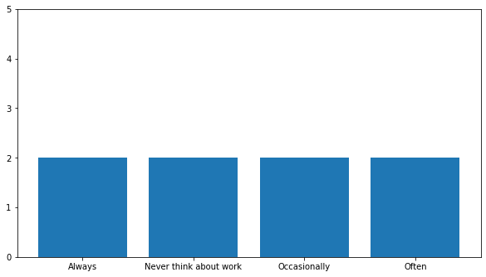

Government employees agree that they are able to balance their work life irrespective of the fact whether they worry about their work after office timing.

The employee who always think about the work after office timing is also able to balance and the employee who never think about the work after office timing also agree about balancing the work life.

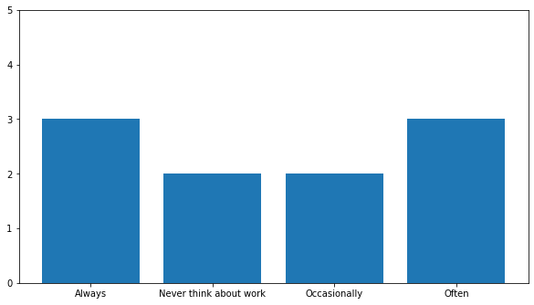

Private employees who think more about their work after office timing are neutral about the fact they can balance their work life.

Employees who occasionally think or never think about the work after office timing agree that they balance their work life.

Here we can see that work life balance depends on the thinking of the employees.

From the statistics above we can suggest to the employees that they should not think abot the work after office timing to balance their work life.

**Destress**

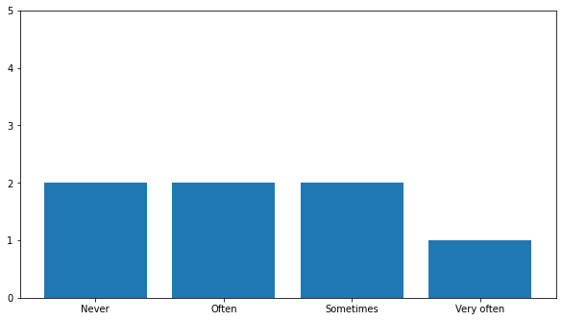

Government employees who get time to destress themselves from the work schedule very often are strongly satisfied that they are able to balance their work life.

Employees who get the time often or sometimes or the people who do not get the time at all agree that they can balance the work life.

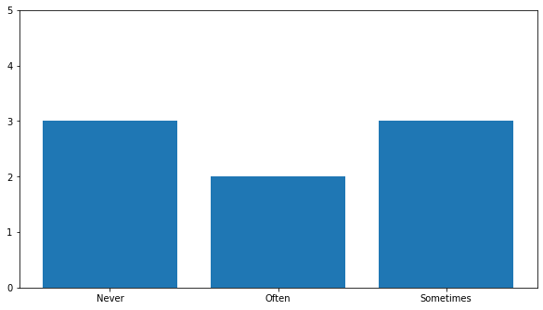

Private employees who never get the time or often get it to destress themselves from their work schedule are neutral about balancing the work-life.

**exercise**

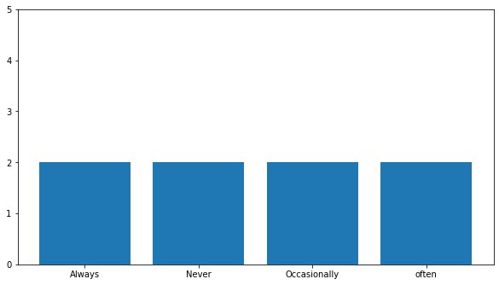

Work life balance of government employees does not depend on whether they do exercise or not.

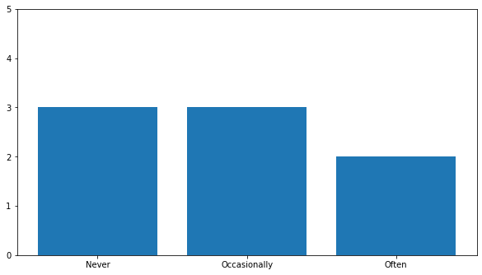

Private employees exercise often agree that they can balance the work life.

Who never exercise or occasionally do are neutral.

**Mode of work**

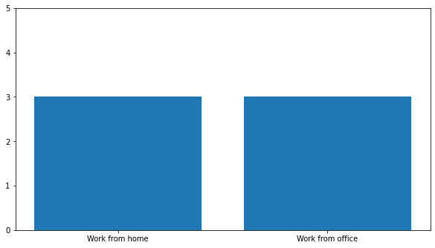

In private industry, employees who think that work from home is convenient to work

And who think work from office is convenient, both types of people share neutral opinion about balancing the work life.

So it is work load that matters , place doesn’t matter whether it’s home or office.

**Commuting time**

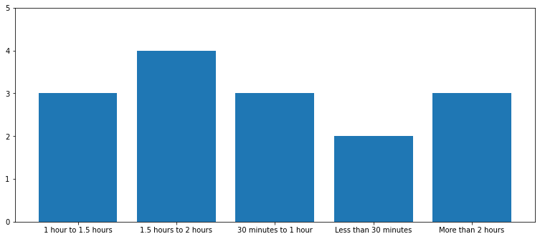

Private employees who require less time (< 30 min) to come to the office agree that they can maintain the work life balance.

People who require 1.5 to 2 hrs are dissatisfied with the fact that can balance the work life.

Because travelling is time consuming for them and eventually might get less time for their family.